AFFINITY CASUAL FUN DAY
Bishopdale Community Centre
13 Bishopdale Court
Bishopdale
Sunday 14th February 2027
9am – 1pm
- Teams can March twice
- Raffles $5.00 for 6 entries
- $2.00 Scratchie Raffles
- Built in Seating – please avoid taking up seating with bags/uniforms
- Full sized basketball court
- Music – The music must be USB Sticks only (Please ensure you only have your 1 piece of music on it)
- Entry is $10.00 per Marcher
- Payment & Registrations are required by 22nd December 2026 to be sent to sharon_wyllie@xtra.co.nz See registration Form
- Any questions please contact:
Delys Dixon del.40@xtra.co.nz
Shelley Alps w_malps@yahoo.co.nz

Draft Timetable
9.00am | Doors Open – Please no entry prior to 9am
9.30am | Coaches Meeting/hand in music
9.45am | Teams assemble for March Past
 | Opening Speeches
10.15am | Marching begins – Each team can march twice
11.25am | Assemble for Maze March
12.00pm | Speeches & Raffle Draw
1.00pm | Join us at Tavern Harewood for a drink

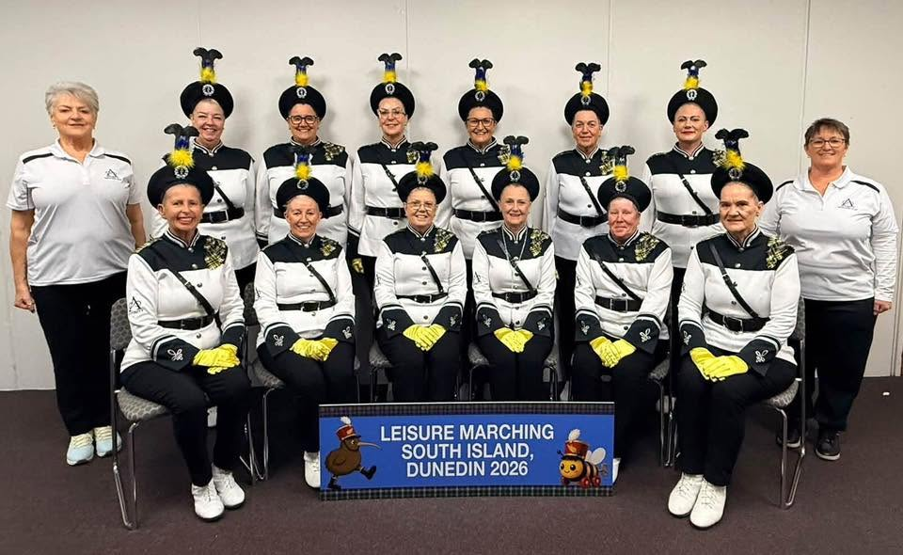

AFFINITY CASUAL FUN DAY – REGISTRATION FORM

Team Name
Number of Marchers
Colours
Coach
Leader
Team Contact
Contact Phone #
Email Address

- Payment & Registrations are required by 22nd December 2026 to be sent to sharon_wyllie@xtra.co.nz See registration Form
- Music – The music must be USB Sticks only (Please ensure you only have your 1 piece of music on it)
- Entry is $10.00 per Marcher

Please deposit your registration $$ into the following ANZ account:
AFFINTIY MARCHING TEAM – 01-0877-0742748-00
Please use your Team name as reference.

We look forward to seeing you all there for a fun day of Marching.
