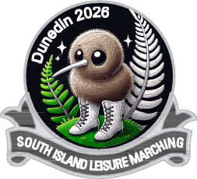
DUNEDINITES and DUNEDIN 60 PLUS LEISURE MARCHING TEAMS
Hosting South Island 2026- 17th October 2026 Breeze Arena (Edgar Centre)

TIMETABLE & DRAW (Timing is Approximate)

9.00am Doors Open

9.30am Delegates Meeting

10.00am March Past & Opening

11.00am Team No 1 to Team No 15

12.30pm Lunch Break
(Entertainment Rock Choir & 60 plus Line Dancing

1.30pm Teams 16 to 34

3.00pm (approx.) Handover to Pioneers of Canterbury, Maze March &
Raffle Draw

4.00pm Deadline Hall to be cleared to allow set up for Night function

7.00pm – 11pm Night Function

ORDER OF MARCH

- Dunedin 60 Plus Leisure Marching Team

- Dunedinites Leisure Marching Team

- Temuka Leisure Marchers

- Kon Tiki Leisure Marchers

- Invercargill Diamonds

- Foveaux Pearls

- Wakatu Guards

- Casa’ n’ ova Rebels

- Kaiapoi Club Gold

- Pegasus Belles

- Kaikoura Senior Moments

- Gore Golden Cavaliers

- Funseekers Leisure Marchers

- The Gate Leisure Marchers

- Aorangi Guards

- Waihope Militaires

- Waimea Stars

- OPS Guards

- Canterbury Phoenix

- Step Sisters

- 3 Decades

- Southern Gold

- Deep South Debonaires

- McCullough Guards

- Southern Cross Millenium

- North Canterbury Classics

- Mid Canterbury Magic

- Canterbury Belles

- Wallace & Cooper

- Papanui Paraders

- Otago Highlandettes

- Royal Guards

- Affinity

- Pioneers Of Canterbury

