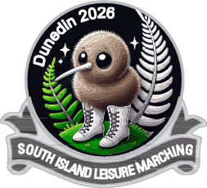
REGISTRATION FORM

SOUTH ISLAND LEISURE MARCHING EVENT – 17th October 2026
Hosted by Dunedinites and Dunedin 60 plus Leisure Team
Venue : Breeze Arena (Edgar Centre)
TEAM NAME:
CITY/TOWN:
TEAM COLOURS:
LEADER:
COACHES:
NUMBER OF MEMBERS IN TEAM (including coach/es) |  | Total for entry:  $______.____
NUMBER ATTENDING NIGHT FUNCTION: |  | Total for function:  $______.____
BADGES: | Total: | $______.____
Contact Details:
Name:
Email:
Phone number:
MUSIC:
Please email Music to marchingotagomusic@gmail.com noting your team name and that it is for 2026 South Island Display Day.

COST:
$35.00 per person. Payment details: 06 0901 088 5088 00 – 2026 SI Leisure Display. Please enter your team’s name as reference.

Night function Cost is also $35.00 per person. Please advise if any of your members have any dietary requirements.

Badges are $15.00 each.

Email: s.i.2026dun@gmail.com or phone Glenys 021 133873

