DUNEDINITES and DUNEDIN 60 PLUS LEISURE MARCHING TEAMS

Hosting South Island 2026
17th October 2026

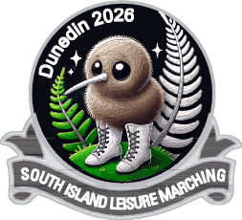
NIGHT FUNCTION INFORMATION
Table No Team & Number at table

1. Dunedin 60 Plus Leisure Marching Team (12)
2. Dunedinites Leisure Marching Team (10)
3. Temuka Leisure Marchers (7)
4. Kon Tiki Leisure Marchers (10)
5. Cas’ n’ ova Rebels (12)
6. McCullough Guards (13)
7. Wakatu Guards (8)
8. Canterbury Belles (7)
9. Kaiapoi Club Gold (5)/ Step Sisters (5)
10. Pegasus Belles (7)
11. Kaikoura Senior Moments (12)
12. Gore Golden Cavaliers (9)
13. Funseekers Leisure Marchers (10)
14. The Gate Leisure Marchers (10)
15. Aorangi Guards (9)
16. Papanui Paraders (10)
17. Waimea Stars (6)
18. OPS Guards (8)
19 & 20 Affinity (14)
21. 3 Decades (8)
22 & 23 Pioneers of Canterbury (16)
24. Southern Cross Millenium (11)
25 North Canterbury Classics (12)
26 Mid Canterbury Magic (11)
27 Foveaux Pearls (7)

27 Tables
Table 5 & 6 to be beside each other
8 Gluten Free, I diabetic, 1 allergy (No capsicum or Pepper), I Vegetarian & 2 Vegan

