Hello fellow marchers 👋
We are delighted to confirm that 11 teams will be joining us for our Affinity Casual Marching Day. Thank you all so much for supporting this event, we are really looking forward to a great day of marching, music, and community.
Venue: Bishopdale Community Centre
Address: 13A Bishopdale Court, Bishopdale
Date: Sunday 1st February 2026
What to expect on the day:
• Each team will have the opportunity to march twice
• Cafés are close by
• $5 Raffles available – please remember to bring some cash
• $2 scratch boards will also be available

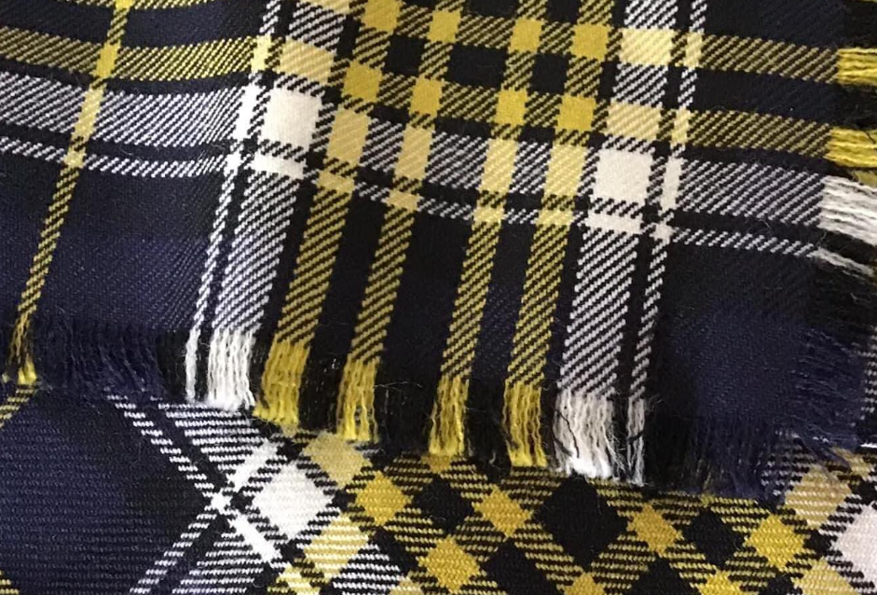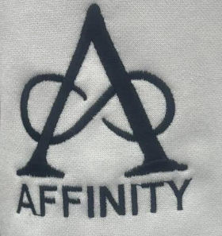

Proposed Timeline (subject to minor changes on the day):
• 9:15am – Doors open (Please do enter the hall earlier, as we can’t access the hall until 9am, we will be setting up prior to 9.15am. You are welcome to use the changing rooms early but please remain out of the hall.)
• 9:30am – Coaches’ meeting (music to be provided on USB –(one piece)
• 9:35am – Teams assemble for March Past
March Past
Opening Speeches
• 10:00am – Marching begins
• 12:30pm – Assemble for Maze March
• 12:45pm – Speeches and raffle draws
• 1:00pm – Social time at the Harewood Tavern (all welcome)
Important Notes:
• Built-in seating is limited (we have approximately 110 marchers plus spectators), so please be mindful of seat use
• If possible, please place bags and uniform gear back into cars
• Please follow usual marching etiquette – enter and exit only at the end of performances
• Music must be supplied on a USB stick with one piece of music only
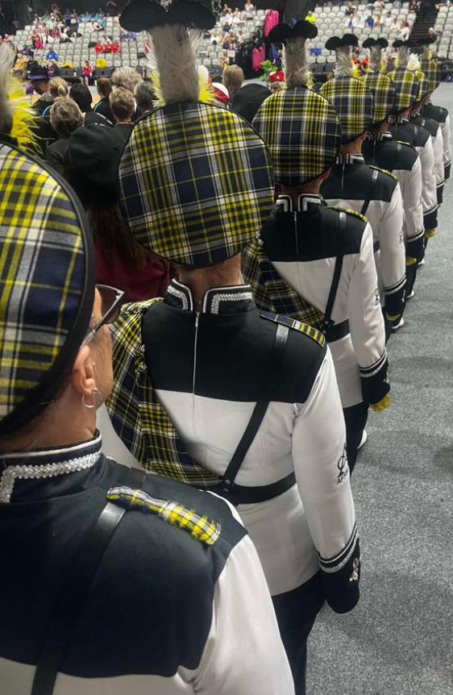
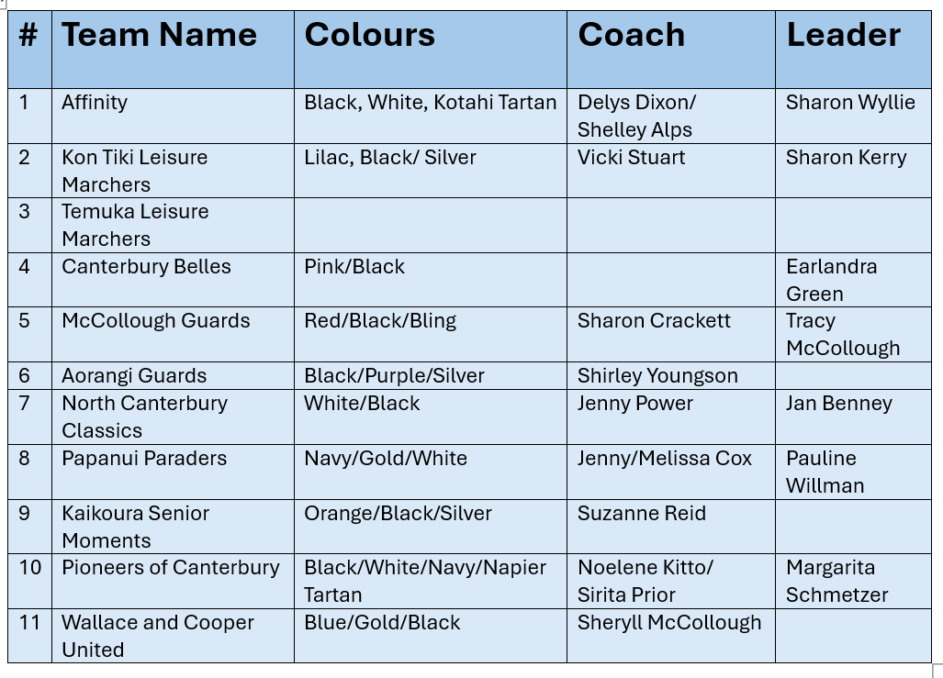
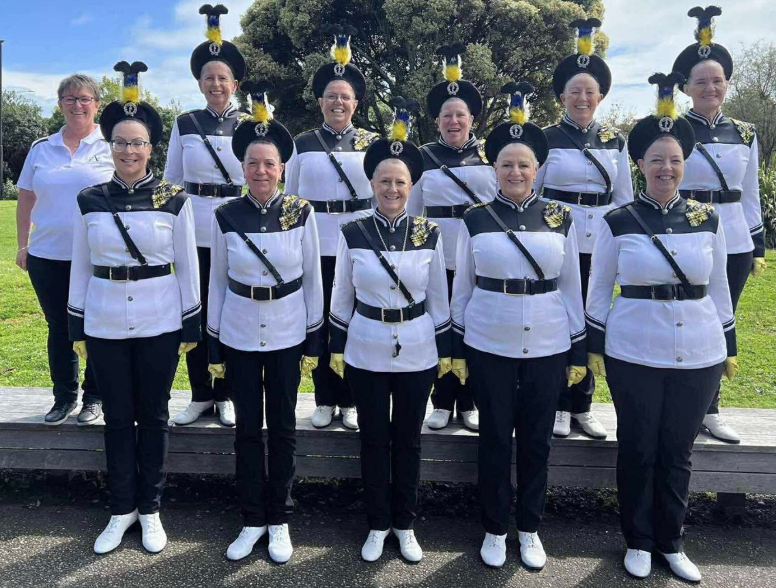
Many thanks to all

