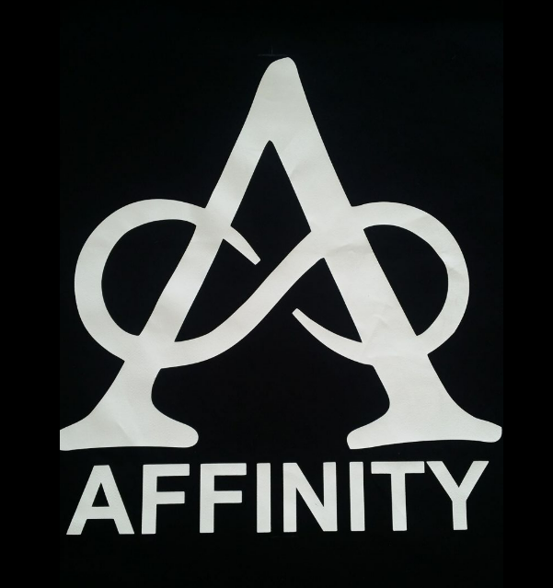
Affinity Casual Marching Day

Hello Fellow Marchers

Our 2026 casual marching day planning is well underway.

When: Sunday - 1st February 2026
Where: Bishopdale Community Centre, 13 Bishopdale Court Bishopdale

- A great Opportunity to have a run through before Nationals
- Teams can march twice
- Café close by
- Raffles $5 for 6 entries

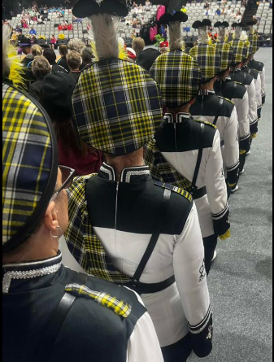
Draft Timetable

9.00am | Doors open – Please no entry prior to 9am
9.30am | Coaches meeting/hand in music
9.45am | Teams assemble for march past
 | March Past
 | Opening Speeches
10.15am | Marching begins - Each team can march twice
11.25am | Assemble for Maze March
12.00pm | Speeches and Raffle Draw
1.00pm | Join us at the Bishopdale Tavern for a drink

The venue is a full-sized basketball court. Please3 ensure you routine can be perform within these dimensions. (Seating is available)
Registration Fees
Registration is $10 per Marcher.
Please deposit your registration $$ into the following ANZ account.
- Affinity Marching Team - Account number: 01- 0877 -0742748 – 00
- Please use your team’s name as a reference.
Payment and registrations are required by 22nd December 2025.

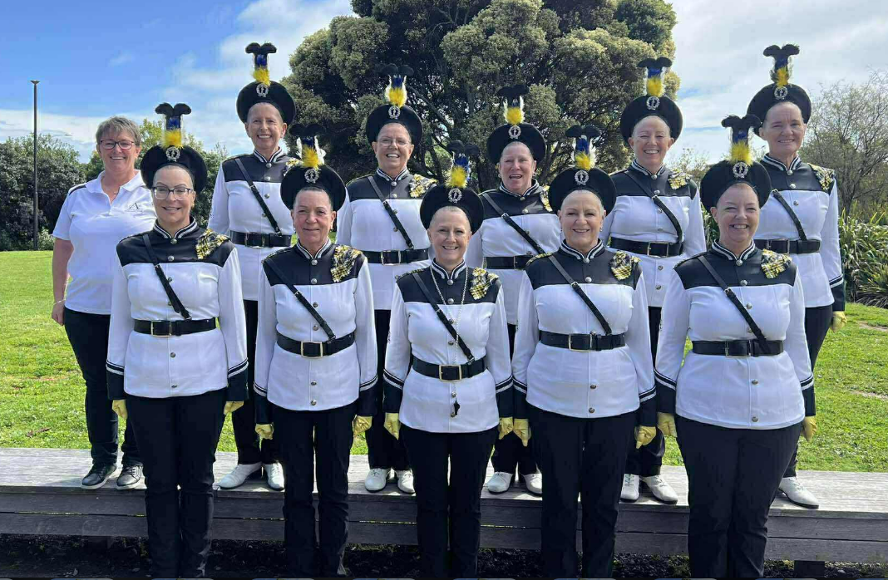
Registration Form

Team Name
Number in Team
Colours
Coach
Leader
Team Contact
Contact Phone #
Emails Address

Payment and registrations are required by 22th December 2025
Emails all entries to: micheleharker1@gmail.com

If you have any questions, please contact:
Delys Dixon del.40@xtra.co.nz
Shelley Alps w_malps@yahoo.co.nz
Important Information to Note
- There is built in seating only, please avoid taking up seating with bags/uniform
- Music – The music will be USB sticks only (Please ensure you only have your 1 piece of music only.

