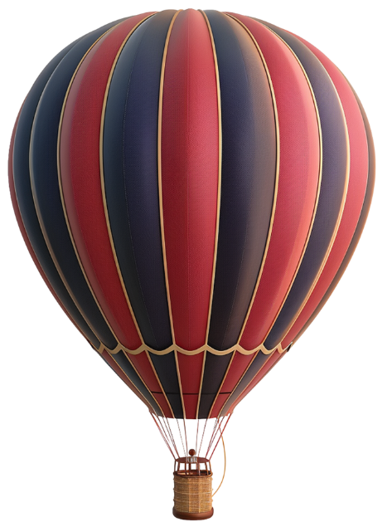
Registration Form
Leisure Marching Nationals
27 & 28 March 2026
Hosted by:
McCullough Guards
MainPower Stadium
289 Coldstream Road, Rangiora

Team Name: _____________________________________________
From (City/Town): _____________________________________________
Team Colours: _____________________________________________
Leaders Name: _____________________________________________
Coaches Name: _____________________________________________
Number in Team (including coach): _____________________________
Contact Details:
Name: ____________________________________________
Email: ____________________________________________
Phone: _____________________________________________________

Are you flexible as to what day you can march? (circle) Yes No
If not, which day would you prefer to march: (circle) Friday Saturday
Note, unlike other events, most teams will march on Friday with only a small number of teams scheduled to march on Saturday.
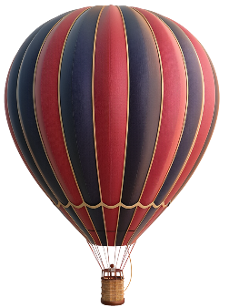
Registration Form Cont.

Registrations close 31 December 2025.
Late entries will incur a $50 penalty.

Registration: $35 per person (including the coach). $____________
Annual website maintenance % hosting fee (per team) $10.00
Total Paid: $____________
Please make payment to the following account by 31 December 2025:
Name of Account: POC Leisure Nationals 2026 Bank: Westpac
Account Number: 03-0823-0079741-017

Please enter the following reference details:
Code: “March Rego”
Description: Please enter your team’s name.
Please email your completed form to Leisurenationals2026@gmail.com


Questions: Please email Leisurenationals2026@gmail.com
Tracey McCullough 027 861 7212
(4.30pm – 8.00pm daily)
Note: PTO for more information
We’d like to learn about your team and its members.
Please answer the following five questions

- What is the name and age of the youngest person in your team?
Name: ___________________________________________ Age: __________
- What is the name and age of the oldest person in your team?
Name: ___________________________________________ Age: __________
- What year did your team form? _______________________________
- What is the name of the person with the highest number of grand/great grand babies/mokopuna and how many do they have?

Name: ________________________________________ Number: __________
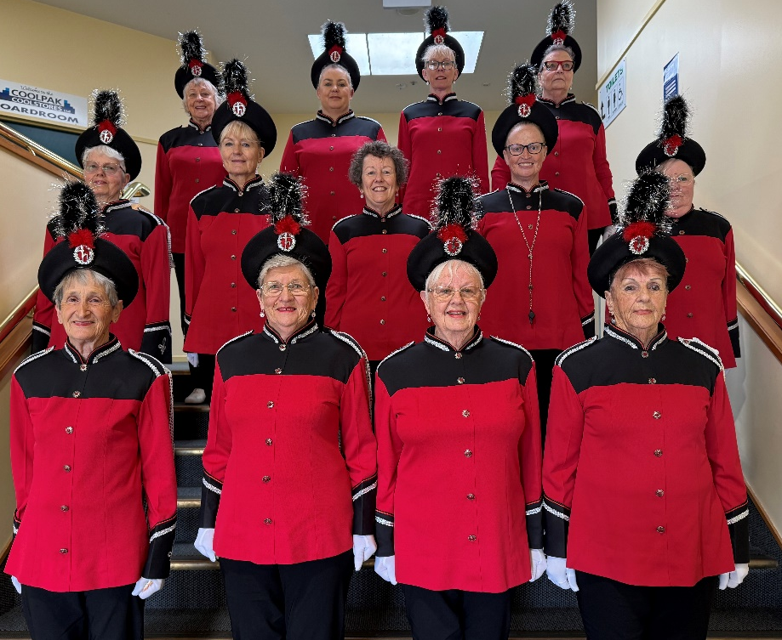
- What is the average age of your team? (To calculate this, write down the age of each person. Add all those numbers together. Divide this number by the number of people in your team). ___________________

McCullough Guards look forward to hosting you.

