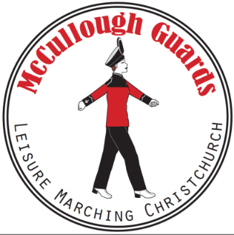

**MCCULLOUGH GUARDS CASUAL MARCHING DAY**

***Hello fellow marchers***

Our 2024 casual marching day planning is well underway and will be very similar to last year.

Details are as follows;

**Rolleston Community Centre**

**94 Rolleston Drive, Rolleston**

**Saturday 6th September 2025**

* Teams can march twice
* There’s a supermarket next door and a café down the road
* Raffles $5 for 6 entries

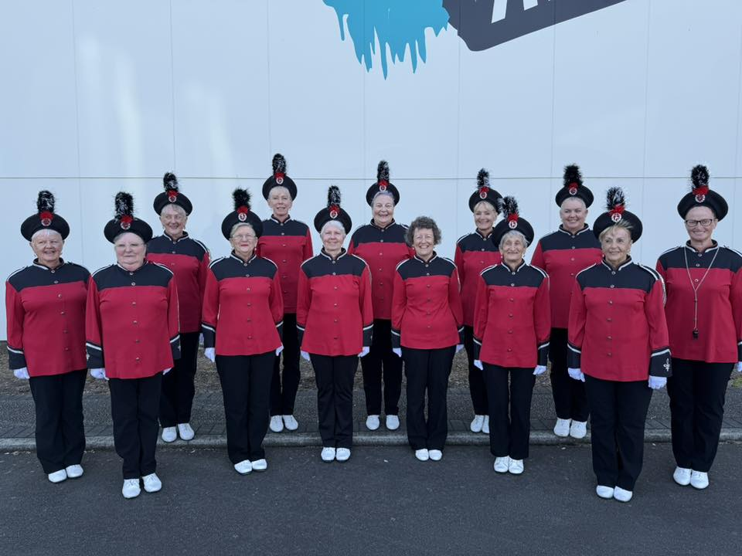

**Draft Timeline**

|  |  |
| --- | --- |
| 9.00am | Doors open – please try not to be early. |
| 9.30am | Coaches meeting/hand in music |
| 9.35am | Teams assemble for the march past |
| 10.50am | Marching begins |
| 12.00pm | Assemble for Maze March |
| 12.15pm | Speeches and Raffle Draw |
| 1.00pm | The Rock Tavern for a drink. You are welcome to join us ☺ |

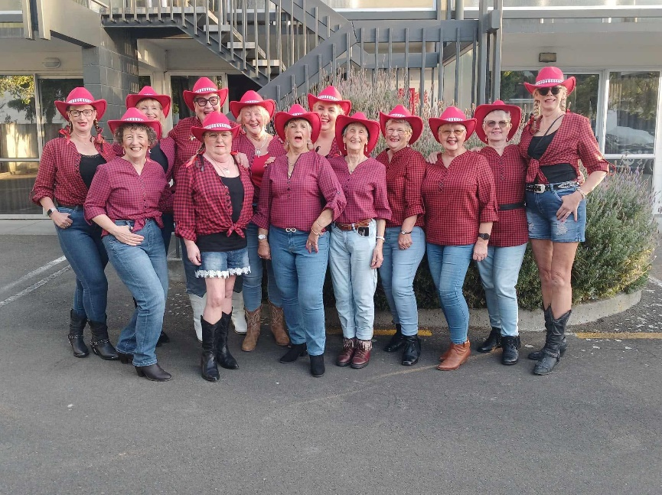

***The venue is a full sized basketball court. Please ensure your routine can be performed within these dimensions. There is some seating available.***

**Registration Fees**

Just like last year, this is only $8.00 per marcher.

Please deposit your registration into the following Westpac Account.

* + McCullough Guards
  + Account Number: 03-0823-0107351-00
  + Please use your team name as a reference

***Payment and registrations are required by 5th July 2025 please***

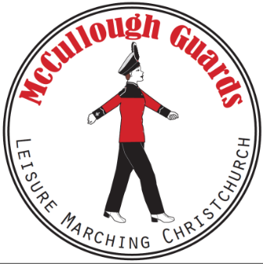

**REGISTRATION FORM**

|  |  |
| --- | --- |
| **Team Name** |  |
| **Number in Team** |  |
| **Colours** |  |
| **Coach** |  |
| **Leader** |  |
| **Team Contact** |  |
| **Contact Phone** |  |
| **Contact Email Address** |  |

***Payment and registrations are required by 5th July 2025 please***

**Any questions, please don’t hesitate to contact me;**

Tracey McCullough, [button72@xtra.co.nz](mailto:button72@xtra.co.nz), 027 861 7212