**Affinity Casual Fun Marching Day**

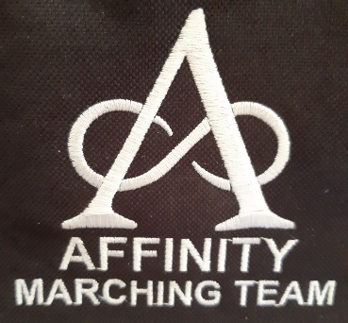**Rolleston Community Centre**

**94 Rolleston Drive,**

**Rolleston, Christchurch**

**Sunday 16th February 2025**

* **A great opportunity to have a run through before nationals.**
* **Teams can march twice.**
* **Entry Fee only $8 per person**
* **Raffles $5 = one entry for all raffles**

**Draft Time Table of events;**

9.30am Doors Open

10.00am Coaches meeting, teams assemble for march past

10.05am March Past/Welcome Speech

10.15am First team starts

11.30am Team marches second time

12.30pm Team Assemble for Maze March

12.40pm Speeches and Raffle Draw

12.55pm Close – The Rock Tavern for a beverage

***Please note these times are approx.***

After the marching has finished, we would love for you all to come across to The Rock Tavern for a drink. Everyone is welcome.

**Registration Form**

|  |  |
| --- | --- |
| Team Name |  |
| Number in Team |  |
| Total Paid (@ $8 per person) |  |
| Colours |  |
| Coach |  |
| Leader |  |
| Team Contact Name |  |
| Team Contact Phone Number |  |
| Team Contact Email |  |

Please deposit your registration fees into the following account:

* Affinity Marching Team
* ANZ
* Account Number 01-0877-0742748-00
* Please use your team name as a reference

Payment and registrations are required by 31st December 2024.

Please email your registrations to DEL.40@xtra.co.nz.

Any questions, please don’t hesitate to contact me:

Delys Dixon, [Del.40@xtra.co.nz](mailto:Del.40@xtra.co.nz) 027 295 2776

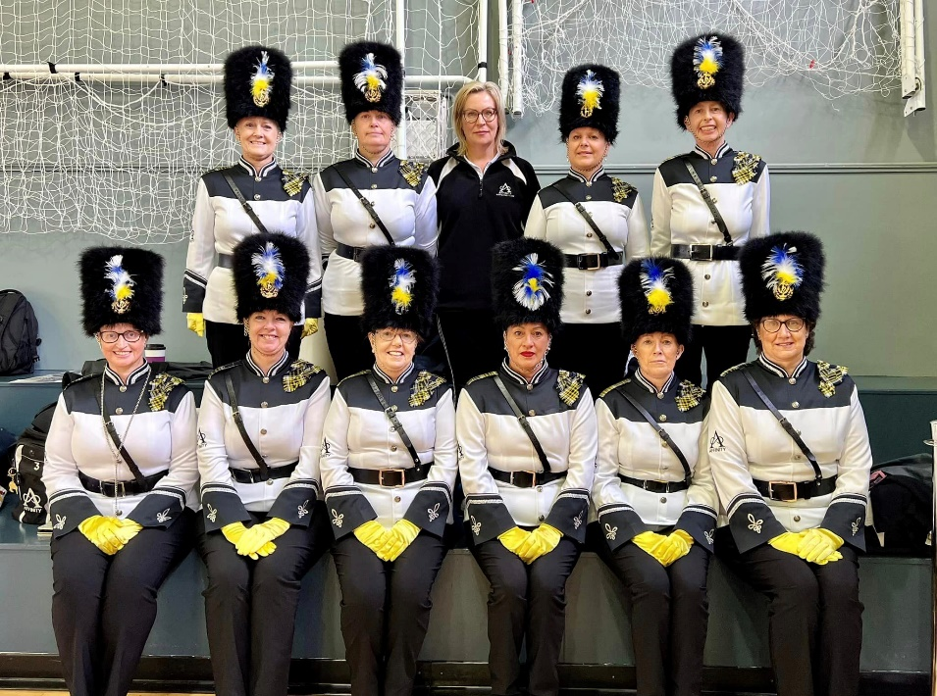

**We look forward to seeing you there.**